**Routing:**

* Routing is the process of directing data packets from src to destn across a n/w.
* It uses RT & protocols to decide the path for data transmission & reliable communication b/w devices.

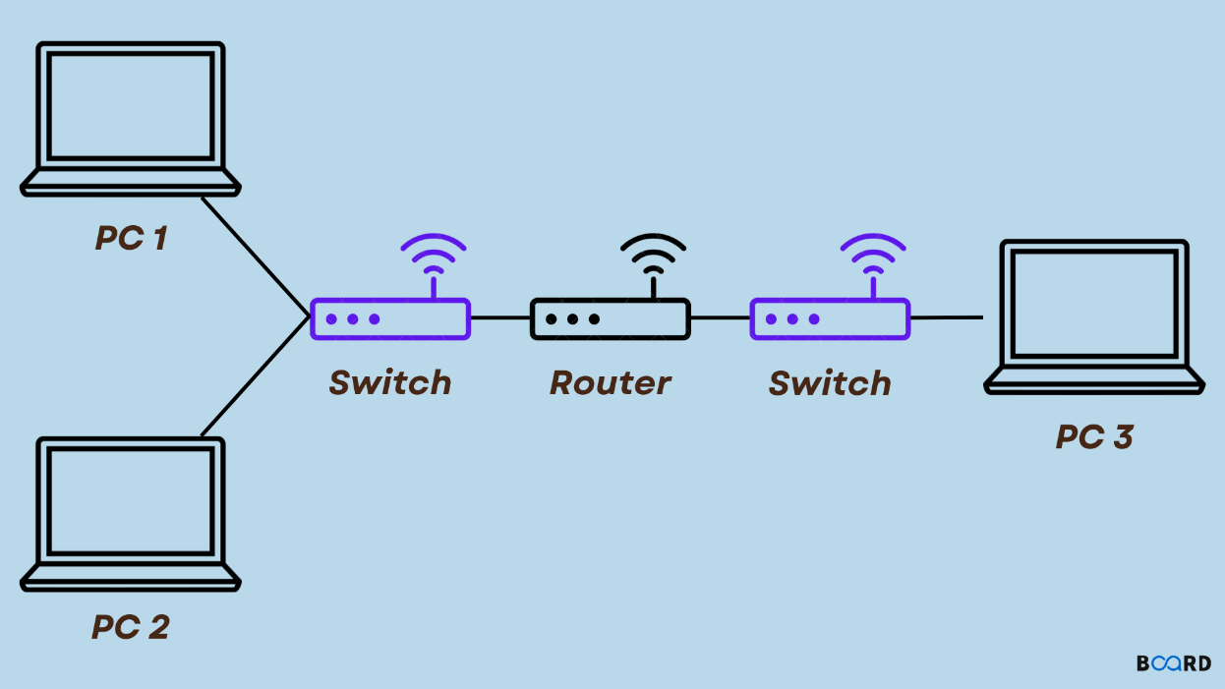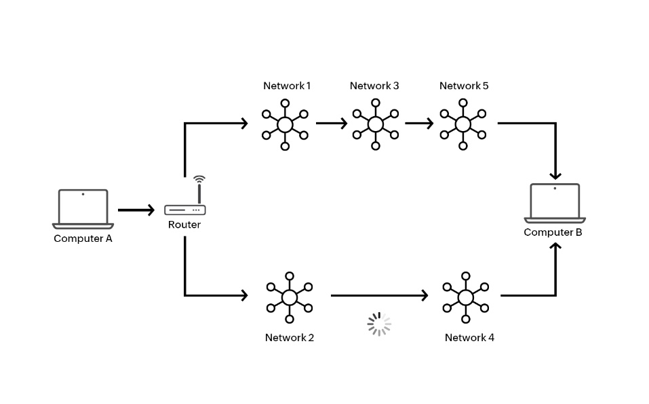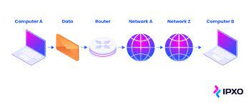

**DNS**: DNS translates easy to remember domain names to computer-friendly IP Addresses, help find mail servers, balances web traffic among servers, redirect requests, performs reverse lookups and speeds up responses through catching.

Eg IP (192.168.10.35) --🡪 Rquest (Google.com)---🡪 web server -🡪DNS server (google.com)192.168.10.35

In AWS we have service called Route53 which is a DNS service here we a hostedzone , if we want to create a records aswell.

We can map our domain to ip address using record type to do different tasks.

**VPN**:1) Virtual private Network it encrypts ur data and routes it through a server, making ur online activities more private & secure.

2)Vpn allow professionals to securely connect to remote servers, access cloud resources and perform maintenance tasks without compromising data security.

